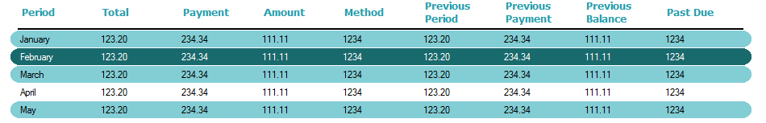

Included images for rounded corners in resources

Add Images in folder and on project

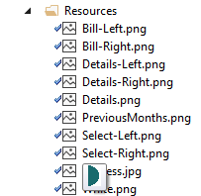

Right click project, and then Properties

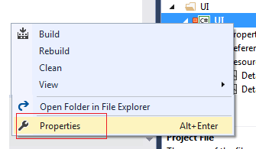

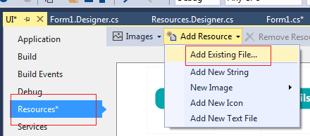

dgBill.BorderStyle = None;

dgBill.DataSource = dtBills;

// disable sort

foreach (DataGridViewColumn dgvc in dgBill.Columns)

{

dgvc.SortMode = DataGridViewColumnSortMode.NotSortable;

}

// IMPORTANTE: CREATE IMAGE COLUMNS

//*********************************

DataGridViewImageColumn imageCol0 = new DataGridViewImageColumn();

DataGridViewImageColumn imageCol5 = new DataGridViewImageColumn();

dgBill.Columns.Add(imageCol0);

dgBill.Columns.Insert(0, imageCol5);

dgBill.Columns[0].Width = 10; // IMAGE

dgBill.Columns[10].Width = 10; // IMAGE

if (dgBill.Rows.Count > 0)

{

// primera fila una linea negra

dgBill.Rows[0].DefaultCellStyle.BackColor = Color.Black;

dgBill.Rows[0].Height = 3;

// primera fila poner png en blanco

Bitmap image = UI.Properties.Resources.White;

dgBill.Rows[0].Cells[0].Value = image;

dgBill.Rows[0].Cells[10].Value = image;

}

// Alternate color and image

for (int i = 1; i < dgBill.Rows.Count; i++)

{

if (i % 2 != 0)

{

dgBill.Rows[i].DefaultCellStyle.BackColor = BackGroundAlternateColor;

Bitmap image0 = UI.Properties.Resources.Bill_Left;

Bitmap image6 = UI.Properties.Resources.Bill_Right;

dgBill.Rows[i].Cells[0].Value = image0;

dgBill.Rows[i].Cells[10].Value = image6;

}

else

{

Bitmap image = UI.Properties.Resources.White;

dgBill.Rows[i].Cells[0].Value = image;

dgBill.Rows[i].Cells[10].Value = image;

}

}

// SET REAL HEIGH OF GRID

dgBill.Height = (dgBill.Rows.Count * 22) + 30;

**Selecting, deselecting row, change images**

private void dgBill_SelectionChanged(object sender, EventArgs e)

{

dgBill.ClearSelection();

}

private void dgBill_CellClick(object sender, DataGridViewCellEventArgs e)

{

int fila = e.RowIndex;

if (fila > -1)

{

dgBill.Rows[fila].DefaultCellStyle.BackColor = BackGroundSelectedColor;

dgBill.Rows[fila].DefaultCellStyle.ForeColor = Color.White;

Bitmap image0 = UI.Properties.Resources.Select_Left;

Bitmap image6 = UI.Properties.Resources.Select_Right;

dgBill.Rows[fila].Cells[0].Value = image0;

dgBill.Rows[fila].Cells[10].Value = image6;

}

}

private void dgBill_RowLeave(object sender, DataGridViewCellEventArgs e)

{

int fila = e.RowIndex;

if (fila > 0)

{

dgBill.Rows[fila].DefaultCellStyle.ForeColor = Color.Black;

if (fila % 2 != 0)

{

dgBill.Rows[fila].DefaultCellStyle.BackColor = BackGroundAlternateColor;

Bitmap image0 = UI.Properties.Resources.Bill_Left;

Bitmap image6 = UI.Properties.Resources.Bill_Right;

dgBill.Rows[fila].Cells[0].Value = image0;

dgBill.Rows[fila].Cells[10].Value = image6;

}

else

{

dgBill.Rows[fila].DefaultCellStyle.BackColor = BackGroundColor;

Bitmap image = UI.Properties.Resources.White;

dgBill.Rows[fila].Cells[0].Value = image;

dgBill.Rows[fila].Cells[10].Value = image;

}

}

}